Turn Traveling with Children into Dream Vacations (Instead of Nightmares!)

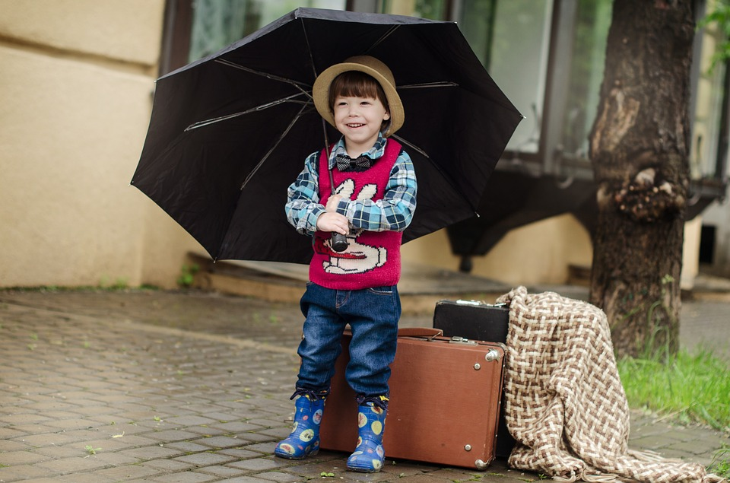
Image courtesy of Pixabay

Do you dread packing the family up for a getaway? Many parents do. Traveling with children can be challenging, and some parents would even call it a nightmare. Instead of feeling stressed about your trip, follow these tips to ease your travel burden and make things more fun and enjoyable for everyone.

Rested and full. Traveling with children can be difficult at best if you start your trip without enough rest. Kids can often mean messes, restlessness and impatience when it comes to traveling. Make sure you and the kids get a good night of sleep to avoid crankiness. You should also fill everyone’s belly with breakfast so nobody is “hangry” from the get-go. Get all your family members bright-eyed and bushy-tailed to start out on the right foot.

Bring goodies. If you expect to spend a fair amount of time in a car or plane, the Travel Channel suggests bringing some new toys, books or games to help pass the time. Kids of all ages love to get something new, and it’ll provide a diversion during downtimes. A few healthy snacks can help curb hunger when awaiting mealtimes, too.

Plan strategically. If your kids are still at a stage where they nap regularly, you can plan flights around that naptime. Watch your connections if you’re using a shuttle, as it will take time to deplane, get bags and get to the shuttle. Also, when waiting for your bags, use that time to go to the restroom. One suggestion is to get a nonstop flight if you can, easing the complications of making connecting flights.

Best seat in the house. Most of us don’t want to feel like we’re a burden to other travelers. When it comes to situations such as changing diapers, slip into the restroom to do so when visiting public places, airports, planes or restaurants. If you’re flying, try get a seat toward the back of the plane so you aren’t climbing over others with your little one, and you might even get more assistance from the attendants by being in the back. Also, while you’re allowed to have youngsters under the age of two ride in your lap on flights, it’s more safe and secure for each child to have a seat of her own. Another recommendation is to keep your kids off the isle seats, since little hands can quickly get into trouble with passing trays of hot foods and beverages.

Pack efficiently. Make sure you have all your essentials at hand including toiletries, wipes, special foods and medications. Travel + Leisure recommends beginning packing a week in advance to ensure you don’t miss anything. To make traveling with babies easier, add a small travel crib to your list of must-haves. It’ll greatly increase your ability to travel, as they are designed to be effective and efficient. Travel cribs are lightweight, portable, and a handy size, which is a key when space is at a premium. Plus, many come with carrying cases, which makes zipping through the airport and carrying to and fro hotel rooms much easier.

International travel. If you plan to leave the country, ensure your children have all the necessary vaccinations well in advance of your departure. Also, if anyone in the family has serious allergies, The Guardian recommends keeping a note handy in the languages appropriate to your destinations. Your note should explain the condition and the severity of the allergy.

Fun for all. Once you reach your destination, you should entertain every member of the family. One suggestion is to talk about the trip in advance and create an itinerary that includes an activity of choice for each family member. That way everyone is filled with anticipation and excitement. Encourage the kids to keep a good attitude and enjoy each other’s choices. It’s a great way to foster a positive, fun atmosphere.

Easy and fun travels await! When many people talk about traveling with their children, the words “easy” and “fun” might not come to mind right away. However with simple and smart preparation, your whole family can enjoy traveling. Thanks to your good plans, family vacations can be a dream!

